Subject "Pharmaceutical chemistry 2"
Lecture 5: Antitussive and mucolytic drugs, surfactants»

Cough is a consequence of reflex excitation of the cough center and is a reflection of a protective mechanism that prevents irritation of the respiratory tract. There are two types of cough: productive and unproductive. Cough is productive (useful) and should not be suppressed if it is accompanied by secretion, exudate, transudate, and agents that have entered the respiratory tract from the external environment. In all other cases, it is called unproductive. With an unproductive cough, antitussives are used.
The production and normal removal of bronchial secretions is one of the key aspects of the normal functioning of the respiratory tract. Physico-chemically, the bronchial secret consists of 2 phases, soluble and insoluble in water. The soluble phase includes electrolytes, whey component, locally synthesized proteins, enzymes. The insoluble phase has a gel-like consistency and consists predominantly of glycoprotein complexes called mucins. Normally, the excretion of mucus and foreign substances and objects adhering to it is carried out by means of mucociliary transport, due to which the speed of mucus movement is from 4 to 20 millimeters per minute. If this mechanism is disturbed, or if foreign objects enter the respiratory tract, which this physiological mechanism is unable to cope with, the cough reflex is activated.
Antitussives as a separate drug group are drugs that suppress the cough reflex at the level of the central or peripheral nervous system. They reduce the activity of the cough center in the brain or the activity of receptors in the airways that “translate” signals to the brain. But to alleviate a strong cough, drugs from other drug groups can also be used (improving sputum excretion, thinning mucus in the bronchi, etc.), which also belong to cough suppressants.
In fact, a good antitussive is a tool that helps solve problems in a particular clinical case. This means that the effect of the drug and the form of its release should be selected taking into account all the features of the cough (type of cough: unproductive, unproductive, productive; its duration, etc.) and the causes of this symptom (infectious, inflammatory / acute or chronic disease, etc.) . It is extremely important to correctly combine antitussives for adults and children with other medicines. So, it is unacceptable to simultaneously take drugs that increase sputum secretion or contribute to its thinning, with a drug that suppresses the cough reflex. This can cause stagnation of mucus in the bronchi and the development of a number of complications. Therefore, when choosing antitussive drugs for coughing in children or adults, you should definitely consult a doctor.
It is a mistake to believe that only a dry, unproductive cough needs treatment. It should be understood that without proper therapy, including without taking the right cough remedy, an unproductive wet cough can quickly transform into an unproductive one. Therefore, with an unproductive wet cough, the doctor may recommend means that facilitate sputum separation in order to prevent its transition into an unproductive form and improve the excretion of infected mucus from the body. And with dry - drugs that stimulate the secretion of mucus, its thinning and / or removal from the bronchi in order to prevent the development of congestion in the respiratory system and the complications caused by this.
Cough medicines include:
- Antitussive drugs
- Expectorants
- Mucolytics
- Bronchodilators
-Surfactants
- Antihistamines
-Combined drugs
Antitussives are medicines that suppress coughs. Usually prescribed in cases where the cough is not physiologically justified. The appointment of antitussives is not an effective measure and leads to a number of side effects.
Classification:
I. Acting on the cough center
reflex action:
• N - cholinomimetics (cytiton, lobeline hydrochloride)
Central action:
• Narcotic (codeine, morphine, dionine, dextromethorphan)
• Non-narcotic (butamirate (intussin, sinekod), glaucine hydrochloride (glauvent) and oxeladine citrate (tusuprex))
II. Suppressing the sensitivity of cough receptors or acting on afferent pathways of regulation
• local anesthetics (lidocaine)
• drugs of mixed action (Prenoxdiazine).
Cititon
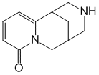
(1R)-1,2,3,4,5,6-Hexahydro-1,5-methano-8H-pyrido[1,2-a][1,5]diazocin-8-one
An alkaloid found in the seeds of the broom (Cytisus laburnum L.) and lanceolate thermopsis (Thermopsis lanceolata R.Br.) plants, both from the legume family (Lugiminosae). White or slightly yellowish crystalline powder, easily soluble in water, ethanol, chloroform.
Excites n-cholinergic receptors of autonomic (sympathetic and parasympathetic) ganglia, adrenal medulla and carotid sinus zone. Interacting with n-cholinergic receptors of carotid glomeruli causes short-term reflex stimulation of the respiratory center of the medulla oblongata. Excitation of n-cholinoreactive structures of the chromaffin tissue of the adrenal glands is accompanied by an increase in the release of epinephrine, which, in combination with stimulation of the sympathetic ganglia, leads to an increase in blood pressure. The hypertensive effect can be used in circulatory depression and other hypotensive conditions.
It is used in the treatment of dry cough.

Lobeline hydrochloride
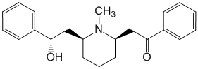
Lobelin (Lobelinum) is an alkaloid contained in the plant Lobelia inflata L., fam. bellflowers (Campanulaceae). In medical practice, it was used as an analeptic, as a respiratory stimulant, as an aid in smoking cessation.
Codeine
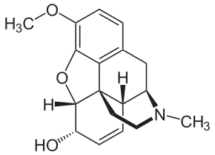
(5-α, 6-α)-7,8-didehydro-4,5-epoxy-3-methoxy-17-methylmorphinan-6-ol
Codeine - 3-methylmorphine, an opium alkaloid, is used as a centrally acting antitussive drug, usually in combination with other substances. It has a weak narcotic (opiate) and analgesic effect, and therefore is also used as a component of painkillers.
By the nature of the action, codeine is close to morphine, but the analgesic properties are less pronounced; the ability to reduce the excitability of the cough center is strongly expressed. To a lesser extent than morphine, it depresses respiration. Antitussive agent of central action; phenanthrene alkaloid. Opiate receptor agonist, reduces the excitability of the cough center. The central antitussive effect is associated with the suppression of the cough center.
It is used for unproductive cough (bronchopneumonia, bronchitis, emphysema).

Morphine
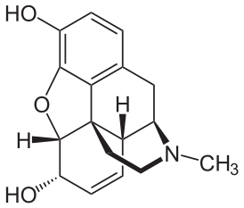
(5α,6α)-didehydro-4,5-epoxy-17-methylmorphinan-3,6-diol
Morphine (on behalf of the ancient Greek god of good dreams Morpheus - Μορφεύς or Μορφέας) is the main alkaloid of opium, the content of which in opium is on average 10%, which is much more than the content of other alkaloids.
Stimulates mu-, delta- and kappa subtypes of opioid receptors. It inhibits the interneuronal transmission of pain impulses in the central part of the afferent pathway, reduces the emotional assessment of pain, the reaction to it, causes euphoria (mood improves, there is a feeling of spiritual comfort, complacency and bright prospects, regardless of the real state of affairs), which contributes to the formation of dependence (mental and physical). Reduces the excitability of the thermoregulation center, stimulates the release of vasopressin. Virtually no effect on vascular tone. In high doses, it exhibits sedative activity, depresses the respiratory, cough and, as a rule, vomiting centers, excites the centers of the oculomotor (miosis) and vagus (bradycardia) nerves.

Ethylmorphine (Dionine)
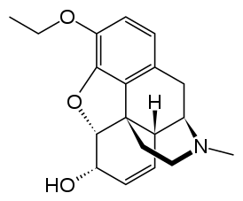
7,8-didehydro-4,5-α-epoxy-3-ethoxy-17-methylmorphinan-6-α-ol
Ethylmorphine (Ethylmorphine hydrochloride, Aethylmorphini hydrochloridum, Dionine). Narcotic analgesic (opioid), antitussive. It is obtained semi-synthetically from morphine.
Stimulates opioid receptors, reduces the excitability of the cough center, is similar in action to codeine.
When introduced into the conjunctival sac, it helps to relieve pain and resolve exudates and infiltrates in inflammatory eye diseases (keratitis, cornea infiltrate, inflammation of the iris, etc.).
It is used internally to soothe cough in chronic bronchitis, pulmonary tuberculosis, etc., and also as an analgesic.
Dextromethorphan
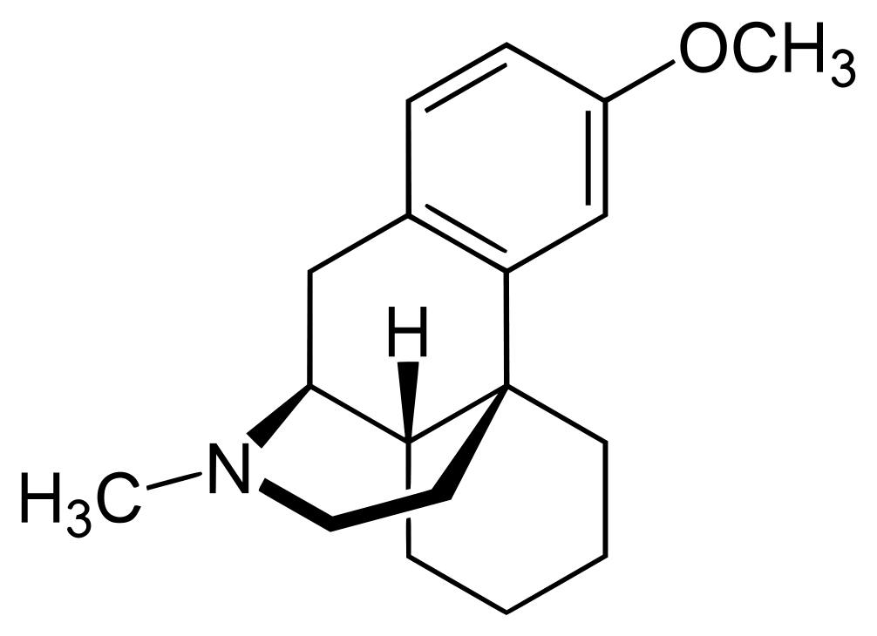
(9alpha,13alpha,14alpha)-3-Methoxy-17-methylmorphinan
Dextromethorphan, DXM is an antitussive. It is an optical isomer of levomethorphan, which is similar to morphine. Due to optical isomerism, it has no opiate effects. Used primarily to replace codeine as a cough suppressant and for recreational use as a dissociative.
It inhibits the excitability of the cough center and suppresses cough, regardless of its origin. It does not have a narcotic, analgesic and hypnotic effect. It has a slight obstipation effect.
Effective against dry cough of any origin, incl. arising from mild irritation of the pharynx or bronchi, caused by a cold or inhalation of any irritating substances.
Application: Dry cough (various etiologies).

Butamirat (intussin, bluecode)
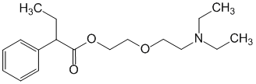
2-[2-(Diethylamino)ethoxy]alpha-ethylbenzeneacetic acid ethyl ester
"Butamirat" (lat. Butamiratum) or "Butamirata citrate" is an antitussive drug that has a direct effect on the cough center. Available as citrate.
Reduces the excitability of the cough center (central action), irritation of the mucous membranes, has a moderate bronchodilator, expectorant and anti-inflammatory effect, improves spirometry and blood oxygenation.
Application: Dry cough of any etiology (including in the pre- and postoperative period, during surgical interventions, bronchoscopy), whooping cough.
Glaucine hydrochloride (glauvent)
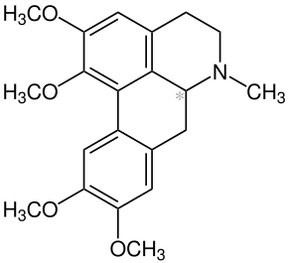
(S)-5,6,6a,7-Tetrahydro-1,2,9,10-tetramethoxy-6-methyl-4H-dibenzo[de,g]quinoline
Glaucine is an alkaloid found in various plant species such as Glaucium flavum[1], Glaucium oxylobum,[2] Croton lechleri[3] and Corydalis yanhusuo.[4]
Antitussive agent of central action. Alkaloid from the yellow plant (Glaucium flavum Crantz) of the poppy family (Papaveraceae). As a medicinal raw material, grass is used, harvested in the phase of stemming, budding or the beginning of flowering from plants of the 1st or 2nd year of life. The herb contains isoquinoline alkaloids of the apomorphine group, the main alkaloid is glaucine.
Selectively inhibits the cough center of the medulla oblongata. Unlike narcotic analgesics, it does not cause respiratory depression, addiction, drug dependence, and does not have an inhibitory effect on intestinal motility. It has weak adrenoblocking properties, can cause a decrease in blood pressure.
Application: Dry cough of various etiologies (including bronchitis, pneumonia, asbestosis, bronchial asthma, pleurisy, whooping cough, tuberculosis).
Oxeladine citrate (tusuprex)
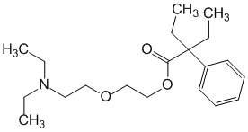
2-[2-(Diethylamino)ethoxy]alpha,alpha-diethylbenzeneacetic
acid ethyl ester
Oxeladin - citrate, alpha-diethylamino-ethoxyethyldiethylphenylacetic acid. Used as a cough suppressant.
It has an antitussive effect, inhibiting the central link of the cough reflex, without inhibiting the respiratory center. Does not cause the phenomena of painful predilection (drug addiction).
Oxiladin is used for all types of coughs. It helps to clear the airways, increases the amount of secretion and blenchial secretion.
Irritant cough.
Allergic cough.
Psychogenic cough.
Treatment of cough in patients with heart disease (it has no side effects on the cardiovascular system).
Infectious cough: tracheitis, bronchitis, pneumonia.
Treatment of cough in the pre- and postoperative treatment of bronchoscopy.
Lidocaine
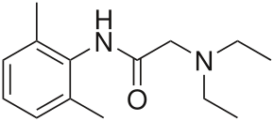
Lidocaine is a drug, local anesthetic and cardiac depressant used as an antiarrhythmic drug.
Inhaled lidocaine can be used as a peripherally acting cough suppressant to reduce the cough reflex. This application can be implemented as a safety and comfort measure for patients who need to be intubated, as it reduces the frequency of coughing and any damage to the trachea that may occur upon recovery from anesthesia.

Prenoxdiazine (Libexin)
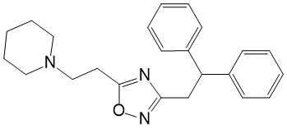
1-[2-[3-(2,2-Diphenylethyl)-1,2,4-oxydiazol-5-yl]ethyl]piperidine
Prenoxdiazine is a synthetic antitussive drug.
It is an antitussive agent of peripheral action. The drug blocks the peripheral links of the cough reflex due to the following effects:
• Local anesthetic effect, which reduces the irritability of peripheral sensitive (cough) airway receptors;
• Bronchodilatory action, due to which there is a suppression of stretch receptors involved in the cough reflex;
• A slight decrease in the activity of the respiratory center (without respiratory depression).
The antitussive effect of the drug is approximately equal to that of codeine. Prenoxdiazine does not cause addiction and drug dependence. In chronic bronchitis marked anti-inflammatory effect.
It is used as an antitussive agent for catarrhs ​​of the upper respiratory tract, acute and chronic bronchitis, bronchopneumonia, bronchial asthma, emphysema, etc. It can be used before bronchoscopy and bronchography (in combination with atropine).

Expectorants
Expectorants - a set of drugs that ensure the removal of bronchial secretions from the respiratory tract.
According to the mechanism of action, two groups of drugs are distinguished:
Stimulating expectoration (secretory drugs);
Reflex stimulating expectoration. When using this subgroup of drugs, an irritating effect on the gastric mucosa occurs, which in turn causes irritation of the cough and vomiting center located in the medulla oblongata. An increase in its activity leads to an increase in the synthesis of liquid bronchial secretions, and an increase in the severity of the cough reflex. The time of action of the drug is relatively short, with an increase in the dose, in addition to the cough center, the vomiting center is also activated, the patient experiences severe nausea, and vomiting is possible. Examples of such drugs are: licorice root, thermopsis, sodium benzoate, essential oils (eucalyptus, terpene).
resorptive action. The drugs of this group cause an increase in the secretion of the liquid part of the bronchial secretion, thereby thinning the sputum and facilitating its excretion. A side effect of taking such drugs is nasal congestion, lacrimation. This group includes: sodium iodide, potassium iodide, ammonium chloride, sodium bicarbonate.
The basis for the appointment of this group of drugs is the detection in a patient of chronic or acute respiratory diseases, accompanied by the production of viscous sputum (bronchitis, broncho-obstructive syndrome, bronchiectasis). It should be understood that this group of drugs is auxiliary, alleviating the patient's condition, improving the quality of his life, but not eliminating the very cause of the disease. Therapy with expectorants should be combined with adequate etiotropic therapy.

Liquorice root
Glycodin
Glycyrrhizic acid
thermopsis
Mirtin
Ivy leaf extract
Terpinhydrate
Terpincode
Essential oils (eucalyptus, terpene).
Pectussin
Guaifenesin
sodium benzoate,
sodium iodide,
potassium iodide,
ammonium chloride,
sodium bicarbonate
Mucolytics
Mucolytic drugs (lat. mucus - mucus + other Greek λιτότης - simplicity, smallness, moderation) - drugs that thin sputum and facilitate its removal from the lungs.
The peculiarity of the action of mucolytic agents is that they thin the sputum, practically without increasing it in volume (due to breaking the disulfide bonds of acid mucopolysaccharides).
Mucolytics are used in acute and chronic bronchitis, pneumonia, cystic fibrosis, bronchial asthma; to provide a pathogenetic effect on the process of inflammation in the respiratory tract.
Popular mucolytics:
bromhexine, ambroxol, acetylcysteine, mukaltin.
There are various classifications of mucoactive drugs. For practical application, the following classification is most convenient:
secretomotor (reflex and resorptive action);
mucolytic (proteolytic enzymes and synthetic).
Secretory, or expectorant, drugs increase the functional activity of the ciliated epithelium of the bronchi and peristalsis. The use of such funds is limited, since in the presence of a thick secret, their effect is insignificant. The most widespread use is in synthetic mucoactive drugs.
Nebulizers can be used to effectively deliver mucolytics to the bronchi.
proteolytic enzymes. They cause the destruction of peptide bonds in glycoprotein complexes, which leads to a decrease in the viscosity and elasticity of sputum. Currently, their use is limited by the risk of developing allergies and bronchospasm. The drugs in this group include: trypsin, chymotrypsin, chymopsin, ribonuclease.
Cysteine ​​derivatives (acetylcysteine). Provides cleavage of disulfide bonds between the proteins of the mucus glycoproteins, which leads to a rapid and pronounced liquefaction of sputum. Caution should be used in debilitated patients, and in cases where dilution of liquefied sputum may be difficult.
Mucoregulators. Preparations of a relatively new group of expectorants. An important feature of these drugs is their ability to increase the amount of pulmonary surfactant. In addition, by stimulating the synthesis of glycoproteins, they even out the content of the mucous and liquid parts of sputum. The work of mucociliary transport is activated indirectly due to an increase in the amount of surfactant. This group of drugs includes bromhexine, ambroxol.
Acetylcysteine
Carbocysteine
Bromhexine
Ambroxol
Mucolytic
trypsin
Chymotrypsin
Chymopsin
Ribonuclease
Bronchodilators
Bronchodilators are a pharmacological group of symptomatic drugs that directly relieve bronchospasm and are used in the treatment of bronchial asthma and chronic obstructive pulmonary disease and some other diseases.
These include drugs that block bronchospasm in various ways:
β2-adrenergic agonists
Non-specific β-agonists (beta-agonists, β-agonists, BDA)
Orciprenaline, Isoprenaline
Specific β2-agonists (beta-two agonists, β2-agonists, β2-adrenergic agonists):
short-acting (BDAK):
salbutamol, fenoterol, terbutaline, hexoprenaline, clenbuterol
long (prolonged) action (BDAP):
salmeterol, formoterol
for oral administration (BDAv): saltos
Antagonists of M-cholinergic receptors (M-anticholinergics, anticholinergics, anticholinergics) -
ipratropium bromide, tiotropium bromide, glycopyrronium bromide, etc.
Myotropic antispasmodics:
Theophylline, xanthine derivatives
Adrenalin
Glaucine
Some analeptics (Etimizol)
The alkaloid glaucine depresses the cough center without affecting respiration. It has a mild bronchospasmolytic and adrenolytic effect and does not cause addiction and dependence.
Ephedrine hydrochloride is an adrenomimetic agent of direct (stimulates alpha and beta receptors) and indirect (suppresses amino oxidase activity) action. Causes the release of norepinephrine and adrenaline from their depot. Ephedrine has an antispasmodic effect on the smooth muscles of the bronchi. It relaxes the bronchial muscles for a long time, which is due to a pronounced stimulating effect on beta2-adrenergic receptors. Under the influence of ephedrine, the swelling of the bronchial mucosa decreases and their lumen expands. Pharmacological studies of Broncholitin® syrup show that it reduces the spasmodic effect of histamine on the bronchi.
Pseudoephedrine
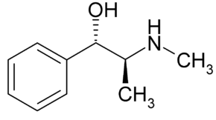
/S-(R*,R*)/-alpha-/1-(methylamino)ethyl/benzenemethanol (as hydrochloride, resinate or sulfate)
Pseudoephedrine is an adrenomimetic, vasoconstrictor, bronchodilator, anticongestant drug. An alkaloid isolated from the shoots of horsetail ephedra (Ephedra equisetina BGE.), which is contained together with ephedrine.
Pseudoephedrine has been proposed for use in adults with bronchial asthma (in mild to moderate forms) and asthmatic bronchitis. Currently, there are other effective bronchodilators (orciprenaline, fenoterol, salbutamol, etc.), methylxanthines (teopek, etc.), anticholinergics (troventol, atrovent, etc.).

Surfactants
Surfactant (from the English surface active agent - “surfactant”, can also be used under the names of anti-atelectatic factor, surface-active factor) - a mixture of surfactants lining the pulmonary alveoli and the bronchial tree from the inside (that is, located on the border of the air -liquid). Prevents the collapse (adhesion) of the walls of the alveoli during breathing by reducing the surface tension of the film of tissue fluid covering the alveolar epithelium. Surfactant is secreted by a special variety of type II alveolocytes from blood plasma components.

Consists of lipids (mainly phospholipids) and proteins[.
Composition of pulmonary surfactant:
Фосфолипиды — 85 % | % фосфолипидов
Фосфатидилхолин: | 7,3
• дипальмитоилфосфатидилхолин | 47,0
• ненасыщенный фосфатидилхолин | 29,3
Фосфатидилглицерол | 11,6
Фосфатидилинозитол | 3,9
Фосфатидилэтаноламин | 3,3
Сфингомиелин | 1,5
Другие | 3,4
Нейтральные липиды — 5 %
Холестерол, свободные жирные кислоты
Белки — 10 %
Сурфактантный белок А | ++++
Сурфактантный белок В | +
Сурфактантный белок С | +
Сурфактантный белок D | ++
Другие
Точный состав белков сурфактанта пока не известен

Surfactant is synthesized and secreted by type II pneumocytes (alveolocytes) (epithelial cells). Due to the surface-active tension, the surfactant lowers the surface tension in the alveolus, preventing it from “falling off”. The surfactant also has a protective effect. The high surface-active properties of the surfactant are explained by the presence of dipalmitoylphosphatidylcholine in it, which is formed in the lungs of a full-term fetus immediately before childbirth.
The surfactant system in premature babies is not developed, which can lead to the development of respiratory distress syndrome in newborns. The surfactant system can also be damaged in adults with injuries, including chemical and thermal ones, as well as with some diseases.
Surfactant deficiency was identified as a cause of respiratory distress syndrome (RDS) as early as 1959. Trials of surfactant replacement in the 1960s were unsuccessful because the drugs used contained only phospholipids and were inefficiently administered with a nebulizer. In the 1970s, Bengt Robertson and Göran Enhörning showed that a natural surfactant containing both phospholipids and proteins can reduce signs of RDS in immature rabbits. In the 1980s, Bengt Robertson and Thor Kerstedt developed the porcine surfactant Curosurf (named after their last names), which was effective in immature animals and was used in pilot clinical trials beginning in 1983.
Endogenous surfactant is a surfactant synthesized in the alveolar cells and in the form of a thin layer lining the inner surface of the lungs. Pulmonary surfactant does not allow alveoli to collapse, has protective properties against alveolar cells, and also regulates the rheological properties of bronchopulmonary secretion and facilitates sputum separation. Violation of surfactant biosynthesis in newborns is manifested by respiratory distress syndrome, and can also be observed in adults with various bronchopulmonary diseases.
The main indication for the use of surfactants is respiratory distress syndrome in premature infants.
Poractant alfa (Curosurf)
Curosurf is a surfactant preparation containing phospholipid fractions (phosphatidylcholine) and low molecular weight hydrophobic proteins (1%) isolated from the lung tissue of pigs. It is used for respiratory distress syndrome associated with surfactant deficiency in newborn (premature) children (weighing at least 700 g). The use of the drug is designed to restore adequate breathing and is allowed only in a clinical setting (taking into account the need for mechanical ventilation and monitoring).

Calfactant (Infasurf)
Calfactant, also known as Infasurf, [1] is an intratracheal suspension derived from natural surfactant in calf lung. It is used in premature infants with lung surfactant deficiency, which causes infant respiratory distress syndrome (IRDS). Pulmonary surfactant is essential for effective ventilation because it changes the surface tension of the alveoli. IRDS is caused by a deficiency of surfactant in the lungs. Calfactant serves as a substitute for natural surfactant.
Exosurf
Exosurf * is a drug whose active ingredient is colfoceryl palmitate. Exosurf has surfactant properties and facilitates lung compliance. Applied, like curosurf *, for respiratory distress syndrome in newborns. Administered as a solution at a dose of 5 ml/kg through the endotracheal tube. If necessary, repeat the introduction at the same dose after 12 hours.
Beractant, also known by the trade name Survanta, is a modified bovine lung surfactant containing bovine lung extract (phospholipids, neutral lipids, fatty acids and bovine surfactant proteins) to which synthetic DPPC, tripalmitin and palmitic acid have been added. The composition contains 25 mg/ml phospholipids, 0.5 to 1.75 mg/ml triglycerides, 1.4 to 3.5 mg/ml free fatty acids, and <1.0 mg/ml total surfactant proteins. In the form of an intratracheal suspension, it can be used for the prevention and treatment of respiratory distress syndrome in newborns. Survanta is manufactured by Abbvie.
Surfactant-BL
Highly purified natural surfactant derived from cattle.
A complex of substances from a mixture of phospholipids and surfactant-associated proteins; reduces the surface tension of the pulmonary alveoli, preventing their collapse and the development of atelectasis. Restores the content of phospholipids on the surface of the alveolar epithelium, stimulates the involvement of additional sections of the lung parenchyma in breathing; promotes the removal of toxic substances from the alveolar space along with sputum. Increases the activity of alveolar macrophages and inhibits the expression and excretion of cytokines by polymorphonuclear leukocytes; stimulates the synthesis of endogenous surfactant by type II alveolocytes and protects the alveolar epithelium from damage by chemical and physical agents.
Antihistamines
Antihistamines are a group of drugs that competitively block histamine receptors in the body, which leads to inhibition of the effects mediated by it.
One of their areas of application is symptomatic therapy / elimination of symptoms in case of colds (including in order to prevent allergies to other prescribed drugs).
Chlorphenylamine
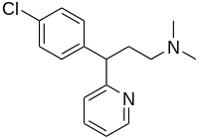
3-(4-chlorophenyl)-N,N-dimethyl-3-pyridin-2-yl-propan-1-amine
Chlorphenamine or chlorpheniramine (Chlorphenamine (INN), chlorpheniramine) is an antihistamine drug used to treat allergic conditions such as hay fever, rhinitis, and hives.[1][2]
It is prescribed orally or with very strong allergic manifestations in injections.
In Russia, not a single drug is registered, where chlorphenamine is the only active ingredient. However, there are several combined preparations containing chlorphenamine as one of the components.
Anticongestants based on phenylephrine
Combined remedies to eliminate the symptoms of acute respiratory infections and "colds" based on paracetamol, phenylephrine and chlorphenamine
Combined remedies to eliminate the symptoms of acute respiratory infections and "colds" based on paracetamol, phenylephrine, chlorphenamine and caffeine.

Combined drugs.
Combined drugs are used as symptomatic therapy for acute and chronic inflammatory diseases of the respiratory tract. Due to the bronchodilator and anti-inflammatory action, when taking these drugs, a dry, obsessive cough is stopped, and due to the expectorant and mucolytic effects, it is transformed into a wet one and the respiratory tract is sanitized.
Some combined preparations contain an antitussive (Stoptussin, Hexapneumine, Loraine), a bronchodilator (Ascoril, Solutan), antipyretic and / or antibacterial agents (Hexapneumine, Lorain). These drugs should only be prescribed under strict indications, since some of them contain medications that are opposite in their action or suboptimal doses of active substances, which reduces their effectiveness. But there are also quite justified combinations of drugs (for example, Ascoril expectorant, which includes guaifenesin, bromhexine and salbutamol).
Thus, the choice of one or another mucolytic agent or their combinations in the complex therapy of inflammatory diseases of the respiratory organs, which are accompanied by a productive cough, should be strictly individual, and the mechanism of the pharmacological action of the drug, the phase and nature of the pathological process, the patient's age and the presence of associated pathology. The simultaneous use of antitussive and mucolytic drugs is undesirable, but a positive effect can be obtained when using mixed-action mucolytics with antitussive properties (erdosteine). In acute bronchitis and pneumonia with scanty sputum, a combination of expectorant drugs and mucolytics is possible, or the appointment of guaifenesin, which has both an expectorant and mucolytic effect, is justified. In diseases of the respiratory organs with an acute and protracted course, accompanied by a cough with abundant mucous sputum, carbocysteine ​​​​(mucoregulator) can be considered the drug of choice, and with viscous and (or) purulent sputum - ambroxol. In children, the drugs of choice are also ambroxol and carbocysteine, in a balanced combination of which the drugs complement each other action of each other, facilitating cough and contributing to the rapid recovery of the mucous membrane of the respiratory tract. In chronic pathology of the respiratory system, N-acetylcysteine ​​is prescribed as maintenance therapy for a long period. In acute respiratory diseases and exacerbation of chronic inflammatory lung diseases, a combination of mucolytic agents with expectorant drugs is possible, but the effectiveness of the latter in chronic pathology of the respiratory tract is low, due to the presence of irreversible structural changes in the bronchial epithelium.
Bronholitin® is a combination drug with antitussive and bronchodilatory effects.
Tablets "Terpinkod" "Kodterpin" "Kodarin" (Tabulettae "Terpincodum"). Composition: codeine or codeine phosphate in terms of codeine 0.008 g, sodium bicarbonate and terpinhydrate 0.25 g each. Terpinkod is prescribed as an antitussive and expectorant.
Tablets "Codelac" "Codelan" "Kodesan". Ingredients: Codeine phosphate 10 mg (8 mg in terms of codeine), sodium bicarbonate 200 mg, licorice root 200 mg, thermopsis lanceolate herb 20 mg.
At the moment, pseudoephedrine is positioned as a decongestant for systemic use (ATC group R01B), including in various combinations: dextromethorphan + paracetamol + pseudoephedrine (drugs "Grippeks", "Gripend", "Daleron Cold 3"), paracetamol + pseudoephedrine + chlorphenamine (drug "AntiFlu").

